**IQ1**-How many customers with balance over $50?

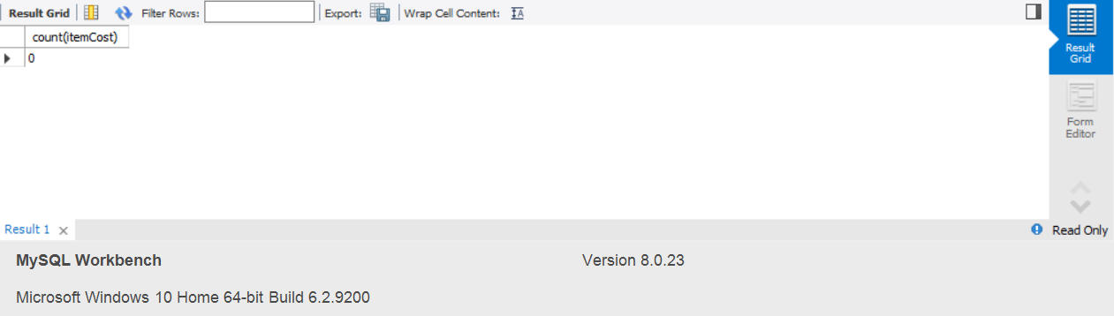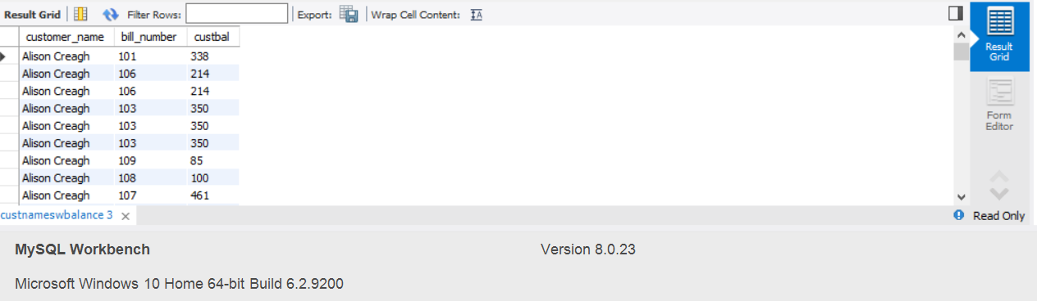

**IQ2**- List all customer names, bills numbers, and each bill balance if the bill balance >0

**IQ3**- List the history of the car with vin = '4USBU53567L660273'. The history must include all tickets information, associated services, and replaced parts’ numbers, descriptions, and used quantities

**IQ4**- Given part number ('390'), List information of all tickets associated with a service that used that part and the used quantity

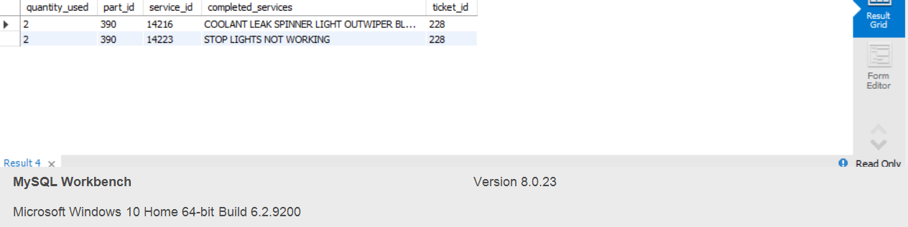

**IQ5**- How many tickets have been made in the interval between the two dates ('2015-01-06', '2015-02-07')?

**IQ6**- what is the total dollar values (labor and parts) associated with tickets in the previous query (IQ5)?

**IQ7**- Given a part ID ('1211'), find the information of all suppliers (vendors) for that part?

**IQ8**- What is the part with highest demand?

**IQ9 -**What is the smallest, largest and average bill total?



**IQ10-**What are the parts that are low in stock (available quantity <3) and require reorder? And show all suppliers for that part?